St. Patrick Presbyterian Church
Emergency Plan
(Last updated 8/3/22)

This document is intended as a starting point for our church relating to emergency situations and is to serve as a guide for our leadership, staff, members and volunteers. This document is a guide but in no way serves as a substitute for making wise and timely decisions in light of real-time events.
Table of Contents

EMERGENCY TELEPHONE NUMBERS 3
OTHER IMPORTANT PHONE NUMBERS 3
The Safety Response Team and its Role 3
Incident Point Person 3
Building Point Person 4
Medical Response Team 5
Safety Response Team Members and Volunteers 5

GENERAL EMERGENCY INFORMATION 6
Medical Emergency Procedures 6
Fire and Smoke Emergency Procedures 7
If the Fire Warning Alarm Sounds 7
Building Evacuation Guidelines 8
Tornado & Severe Weather Emergency 9
- If a Tornado Warning is Announced 9
- Tornado Safety Basics 10
- Tornado Shelter Areas 10
Intruder/Active Shooter Emergency Action Plan 11
- Warning Signs 12

APPENDICES 13
# 1: Threats 13
# 2: Injury/Incident Report 15
# 3: Building Emergency Systems 16
# 4: FEMA Emergency Procedure Graphics 17
- Pandemic 18
- Tornado 19
- Winter Storm 20
- Active Shooter 21
- Chemical Hazard 22
- Earthquake 23
- Flooding/Flash Flooding 24
- Nuclear Detonation 25

QUIZ AND SIGNATURE PAGE 26

EMERGENCY TELEPHONE NUMBERS
For All Emergencies Dial 9-1-1

OTHER IMPORTANT NUMBERS (as of the date of this revision stated on cover page)
Office Number: (901) 861-3803
Executive Director: Chris Bolton, Cell (615) 717-5756
Senior Pastor: Jim Holland, Cell (901) 270-4502
Associate Pastor: Josh Smith, Cell (901) 219-2818
Family Ministry Director: Amy Henson, Cell (901) 481-5215
Office Manager: Wendy Vande Linde, Cell (901) 581-3138
Hospitality Asst: Amanda Cantrell, Cell (901) 605-5537

THE SAFETY RESPONSE TEAM AND ITS ROLE
The Safety Response Team within our congregation is made up of an Incident Point Person, a Building Point Person, a Medical Response Team, along with selected and trained staff members or volunteers. The overall role of the Safety Response Team is twofold:

1. To ensure the immediate notification of the proper authorities (police, fire, medical etc.) via the emergency 9-1-1 system.
2. To facilitate safety and order in the event of an emergency.

INCIDENT POINT PERSON
The Incident Point Person provides leadership mainly for communications in facilitating safety and order in the event of an emergency. Specific responsibilities will include the following:

- Making (or delegation of) the initial emergency phone call to 911 in the event of an emergency.
- Communicating with the emergency agency/agencies involved (e.g., fire department, police, paramedics, emergency management, etc.).
- Lead in formal communications with members, volunteers, and those impacted.
- Helping to provide leadership along with the Building Point Person until personnel with more experience arrive on scene.
- Helping to recruit safety response team members (any additional members, visitors, or volunteers to help if needed in a given situation).
- Helping the Building Point Person to ensure all safety response team members are assigned duties and understand all emergency procedures.

As of the date of this plan, the Incident Point Person will be the Associate Pastor. If the Associate Pastor is not present, then it will fall to the following individuals in this order:

- Associate Pastor (primary)
- Any Active Session Member
- Family Ministry Director
- Hospitality Asst.
- Other St. Patrick Staff Member
- Other St. Patrick Church Member
- Volunteer

BUILDING POINT PERSON
The Building Point Person is a staff member trained to know the floor plans of each building and the emergency evacuation procedures for any emergency—medical, fire, tornado, etc. The Building Point Person may be involved in long-range planning related to building projects and should coordinate with local authorities to make sure the appropriate building codes are met and fire alarm systems in place to help prevent any unnecessary emergencies.

The Building Point Person will be responsible for:
- Providing leadership along with the Incident Point Person until personnel with more experience arrive on scene.
- Coordinating with the emergency agency/agencies involved (e.g., fire department, police, paramedics, emergency management, etc.).
- Lead with the emergency agency/agencies for any needed evacuations or other emergency actions.
- Coordinate emergency planning activities.
- Assist with recruiting safety response team members.
- Schedule staff and session training.

As of the date of this plan, the Building Point Person will be the Executive Director. If the Executive Director is not present, then it will fall to the following individuals in this order:

- Executive Director (primary)
- Office Manager
- Any active Session member
- Other St. Patrick Staff Member
- Other St. Patrick Church Member

MEDICAL RESPONSE TEAM
Medical response team members are volunteer members of the safety response team who have been formally trained in medical emergencies. Responsibilities include the following:

- Providing first aid and medical assistance to those incurring a medical emergency until medical personnel with higher training arrive on scene.
- Conducting a primary assessment of the medical emergency situations and reporting this assessment to appropriate personnel.
- Remaining in charge of a medical emergency situation until professional help arrives.

Church members who have formal medical expertise (physicians, nurses etc.) should immediately identify themselves to the Incident Point Person to help in the time of need.

SAFETY RESPONSE TEAM MEMBERS AND VOLUNTEERS
The safety response team members are staff members or volunteers who understand and are prepared to facilitate a safe and effective response to any emergency situation. All individuals chosen to help should defer to the Incident Point Person and/or Building Point Person in the event of an emergency to keep good order, limit confusion, and not add more alarm in the event of an emergency. Safety response team members should know the location of approved tornado shelter areas in the building.

Responsibilities include the following:

- Building evacuations—responsible for facilitating, as well as, reporting to the Building Point Person that their assigned section has been cleared during an evacuation.
- Intervention procedures as the situations dictate.
- Work in coordination with the Building Point Person to minimize hazards throughout the year.
- If available, maintain emergency texting/phone calls to coordinate with other team members (raise awareness, status updates etc.).

GENERAL EMERGENCY INFORMATION
In the event of an emergency, safety response team member responsibilities may also include the following:

- Knowing how to correctly respond to and summon help for a medical emergency.
- Knowing how to correctly report a fire or smoke emergency using the 911 emergency numbers.
- Knowing the locations of the manual fire alarm pull stations in their area. Manual fire alarms are well marked in red and are located at every major exit to the building.
- Knowing the locations of the fire extinguishers in their area and how to use them. Fire extinguishers are also red and located in 10 areas around the church:
  - Youth Room near laundry closet
  - Youth Room hallway entering back lawn/play area
  - Adult classroom hallway near Parlor
  - Main Office by rear all door
  - Nursery hallway near infant nursery
  - Children’s Sunday School hallway near room 110
  - Children’s area workroom
  - Narthex on west wall behind the Connect Table
  - Sanctuary front left side of stage
  - Main Kitchen
- Knowing how to correctly respond to a fire warning alarm.
- Knowing designated shelter areas and precautions to take in the event of a tornado emergency.
- Becoming familiar with exit routes and knowing alternate exits to correctly respond to a call for an evacuation.
- Closing all opened doors as they evacuate an area.

MEDICAL EMERGENCY PROCEDURES
Call 911 or another appropriate emergency response activation number. Be prepared to give the following information:

- Name and extension.
- Location.
- Number of people involved.
- Nature of injury or illness.
- Remember to stay on the line until help arrives, if at all possible.

Note: Treat minor injuries from supplies in the first aid kits. The kits are well marked and located in at least four well known areas: the Kitchen, the Children’s Workroom area, the Church Office and the Youth Room.

While waiting for professional help do not move the ill or injured person, unless safety considerations necessitate movement or transportation to a safer location. Find the Incident or Building Point persons to help. When professional help arrives:

- Allow responding units to take control of the situation.
- Emergency response team members will stand by to assist as needed.

Regular CPR/First Aid training is recommended for all leaders, especially pre-school and Sunday School teachers.

FIRE AND SMOKE EMERGENCY PROCEDURES
If you detect smoke and/or fire:

- Activate the manual fire alarm. Manual fire alarms are marked in red and located at every major exit to the building.
- Call 911 (move to a safe area before making this call).
  - Give your name, telephone number, and location to the authorities.
  - Describe the situation.
- Find the Incident or Building Point person to help.
- Initiate evacuation procedures for any occupants of the affected building(s) or as directed.
- If you know how to use a fire extinguisher and feel the best course of action is to attempt to extinguish the fire, locate an extinguisher and, without risking injury, attempt to extinguish the fire. Fire extinguishers are red and located in at least four well known areas: the Kitchen, the Children’s Check-in Station, the Church Office and the Youth Room.
- If the fire is beyond the point of a safe attempt to extinguish it, isolate the fire by closing doors in the area before evacuating.

IF THE FIRE ALARM SOUNDS
- Immediately find the Incident/Building Point persons and/or initiate evacuation procedures.

Note: Evacuation route and holding areas should be checked/secured prior to the evacuation, if at all possible, noting a fire alarm could be a ruse to get people to evacuate to an area where they are more accessible or vulnerable to someone wanting to harm them. Evacuation should be toward the main parking lot areas on the south side of the church building bordering W. White Rd. (This is the designated assembly area for all emergencies).

- Assist disabled persons in your area.
- If you encounter smoke, take short breaths through your nose and crawl along the floor to the nearest exit.
- Feel all doors with your hand before opening. If the door is hot, do not open it. If the door is cool, open it slowly, keeping behind the door in case you have to quickly close it to protect yourself from oncoming smoke or fire.
- Proceed to the outdoors.
- Move upwind of the building at least 75 feet away from the building and beyond designated fire lanes. Go to the main parking lots if possible (south side of building, bordering W. White Rd. This is the designated assembly area for all emergencies).
- Do not go to your automobile or attempt to move it from the parking lot. This could hinder access by emergency vehicles.
- Do not congregate near building exits, driveways, or roadways.
- Do not reenter the building until an all clear is issued by the Incident Point or Building Point person. (Note: The all clear should be initially issued by the Fire Department.)

BUILDING EVACUATION GUIDELINES
All safety response team members should know that the emergency evacuation routes for the EAST and WEST wings are through the main hallways leading to the SOUTH side main entrances and parking lots (designated assembly area for all emergencies).

The designated assembly areas outside the main building are the SOUTH side parking lots bordering W. White Rd. Should the designated assembly area be deemed unsafe, the alternate assembly area will be the large vacant grass lot on the NORTH side of the building (through rear entrances).

If a Building Evacuation is Initiated, important “dos” and “don'ts” are:

- Remain calm.
- Follow the instructions of the Building Point Person or emergency response team, if applicable.
- If you occupy an enclosed office, close the door as you leave.
- Use hallways for evacuation. Be alert for other staff, members, and emergency agency personnel who might also be using the hallways.
- Do not return for coats, purses, briefcases, etc, after you have left the area.
- Do not smoke.
- Do not return to your area until the all clear signal is given.

TORNADO & SEVERE WEATHER EMERGENCY GUIDELINES
The National Weather Service has developed a method of identifying storm conditions that foster the development of tornadoes. The classification and definitions of storm conditions are:

- Tornado watch
- Tornado warning
- Other severe weather watch or warning

A “tornado watch” status indicates that weather conditions are favorable for the development of tornadoes. The watch areas are usually large geographic areas, covering many counties or even states that could be affected by severe weather conditions including tornadoes.

A “tornado warning” is an alert issued by the National Weather Service after a tornado has been detected by radar or sighted by weather watchers or by the public. The National Weather Service provides the approximate time of detection, the location of the storm and the direction of movement. A tornado can move from 25 to 40 miles per hour so prompt emergency action must be taken.

During a tornado warning, a cell phone should be used to gather information from the National Weather Service and local weather services. Should a tornado develop which threatens the area, safety response team members should initiate actions to notify and protect all staff, members, and visitors in the facility.

IF A TORNADO WARNING IS ANNOUNCED
When you hear the announcement for a tornado warning:

- Assist disabled personnel in your area.
- Shelter in place by moving to a designated tornado shelter area immediately.
- Move quickly, but do not run.
- Notify the Incident/Building Point Person.
- Shelter in place until you hear an announcement from a member of the safety response team and/or professional personnel that it is safe to return to your area.

TORNADO SAFETY BASICS
Tornadoes and tornado-producing weather conditions are common in Memphis, Germantown, Collierville. Familiarize yourself with the basics of protecting yourself wherever you may be.

If you are indoors, the general responses to a tornado warning are:

- Move away from windows. If you have time, close any window blinds or shades to help prevent flying glass and debris—the cause of most injuries in office buildings.
- Warn others. Encourage them to get to safety immediately.
- Move away from large expanses of unsupported ceilings.
- Move away from building perimeter area.
- Move to an interior room away from windows, to an enclosed room or conference room, a restroom, an interior stairwell.
- If in an interior hallway, away from windows, crouch down as low as possible.
- Once you’ve situated yourself in the safest place you can find, protect your face and head, and stay where you are until an all clear signal is given. (If circumstances change and new dangers are present, seek a different safe place.)
- In general, large rooms and/or rooms with windows are not the best place to shelter.

If you are outdoors, the general responses to a tornado warning are:

- If at all possible, move indoors to an interior room.
- If moving indoors is not possible, take cover near objects that are low and securely anchored to the ground, such as culverts or low retaining walls.

TORNADO SHELTER AREAS
St. Patrick leadership has identified the following areas as best locations for shelter in light of a tornado or severe storm:

1. EAST WING (church offices, youth room, and adult classrooms):
- Primary: Close all adult classroom doors and shelter in the mens/ladies bathrooms, janitorial closet and/or the central hallway near the water fountains if possible.
- Secondary: Close all office doors and shelter in the work/copier area, under the large staff meeting table if possible.

2. WEST WING (sanctuary, narthex, and children/infant classrooms):
- Primary: Shelter in the mens/ladies bathrooms.
- Secondary: Close all classroom doors and shelter in all the inner classrooms with no outside windows (Rooms 102, 106, 108, 110), under tables if available.

INTRUDER/ACTIVE SHOOTER EMERGENCY ACTION PLAN
When a hostile person(s) is actively causing deadly harm or the imminent threat of deadly harm or is barricaded within a building, the RUN, HIDE, or FIGHT procedure should be followed:

- RUN: When there is an active threat, flee the area. Do not run in a straight line. Use trees or other solid objects to block the line of sight. After you're safe, call 9-1-1.
- HIDE: If escape is not possible, hide. Barricade/block the doors, avoid windows, silence your cell phone (including vibrate) and hide silently.
- FIGHT: Only if a last resort and your life is in danger, do what you can to incapacitate or obstruct the actions of the intruder.

Other important points:
- Don't stay in open areas.
- Do not sound the fire alarm. A fire alarm would signal the occupants in the rooms to evacuate the building and thus place them in potential harm as they attempted to exit.
- Turn all lights and audio equipment off.
- Try to stay calm and be as quiet as possible.
- If the person(s) is causing death or serious physical injury to others and you are unable to run or hide, you may choose to play dead if other victims are around you.
- If you are caught by the intruder and are not going to fight back, follow their directions and don't look the intruder in the eyes.
- Once law enforcement arrives, obey all commands. This may involve your being handcuffed or made to put your hands in the air. This is done for safety reasons, and once circumstances are evaluated by law enforcement, they will give you further directions to follow.

Obviously, these General Emergency Procedures cannot cover every possible situation that might occur. Nevertheless, they are a training tool that can reduce the number of injuries or deaths if put into action as soon as a situation develops. Time is a critical factor in the management of a situation of this manner.

WARNING SIGNS

It must be stressed that if you have had contact with ANY INDIVIDUALS who display the following tendencies, you may contact law enforcement and certainly notify leaders in our church:

- Threatens harm or talks about killing others.
- Constantly starts or participates in fights.
- Loses temper and self-control easily.
- Swears or uses vulgar language most of the time.
- Possesses or draws artwork that depicts graphic images of death or violence.
- Frequently initiates domestic violence.
- Becomes frustrated easily and converts frustration into uncontrollable physical violence.

APPENDIX 1: THREATS
In the event you receive a threat call (i.e. bomb threat, armed assault, custody issues), remain calm; if possible, have a pre-arranged signal to alert other staff members to listen to the caller also. If possible, advise the caller that the detonation of a bomb could maim or injure innocent people.

THREAT CHECKLIST (Complete this list if you receive a threat):

Exact time of call: ______________________
Date: ______________________
Exact words of caller:

__________________________________________________________________________________________________________________________________________________________________________________________________________________________________________________________________________________________________________________________________________________________________________________________________________________________________________________________________________________________________________

Caller's voice: (circle)

Male | Female | Adult | Youth | Est. Age:
Black | White | Hispanic | Asian | Other:
Calm | Disguised | Nasal | Rapid | Accent:
Nervous | Angry | Sincere | Slurred | Loud/Other:
Excited | Giggling | Stressed | Crying | Other:

If the voice is familiar, whose did it sound like? ________________________________

Background Noise: (circle)

Music Children Typing Airplanes Machinery Cars/Trucks Other:

Do not hang up! Obtain as much information as possible:

- When is the bomb going to explode?
- Where is the bomb?
- What does it look like?
- What kind of bomb is it?
- Method of activation: mechanical, clock, movement/chemical action?
- Method of deactivation?
- Did you place the bomb?
- Why?
- Where are you calling from?
- What is your address?
- What is your name?

Call received by: _____________________________________________________

Note: In the event you receive a bomb threat:
- Call 911 immediately. Provide the following information:
- Identify yourself
- State: I have received a bomb threat
- Give the church’s location: 710 W. White Road, Collierville TN 38017

REMAIN CALM AND PRAY!

APPENDIX 2: INJURY/INCIDENT REPORT
All injuries should be reported to the Office Manager. It is important to maintain accurate records of any injuries incurred during an emergency in case of insurance or liability questions. The Office Manager (in cooperation with those involved) should complete this report for all injuries, as well as, notify the Executive Director:

Date: ________________________________________
Injured Person: ________________________________________
Completed by: ________________________________________

Where were you when injury occurred:
__________________________________________________________________________________________________________________________________________________________________________________________________________________

Description of injury and how it occurred: (Use back if more space is needed):
__________________________________________________________________________________________________________________________________________________________________________________________________________________________________________________________________________________________________________________________________________________________________________________________________________________________________________________________________________________________________________

Witnesses:
__________________________________________________________________________________________________________________________________________________________________________________________________________________

Action Taken/Medical Treatment Provided:
____________________________________________________________________________________________________________________________________________________________________________________________________________________________________________________________________________________________________________________________________________________________________________________________________________________________________

APPENDIX 3: BUILDING EMERGENCY SYSTEMS

FIRE/SMOKE DETECTION WARNING
The fire/smoke detection control panels are located in the Children’s Wing, in a closet near the nursery rooms. The code to the alarm system is on the control panel.

Fire extinguishers are red and located in at least four well known areas: the Kitchen, the Children’s Check-in Station, the Church Office and the Youth Room.

APPENDIX 4: FEMA EMERGENCY PROCEDURE GRAPHICS

The graphics following this page are provided by the Federal Emergency Management Agency (FEMA) and are updated as new information becomes available. They are provided for general safety policies and procedures to augment your knowledge of what to do in an emergency. You can find the most up to date versions at:

https://www.fema.gov/sites/default/files/documents/fema_shelter-in-place_guidance.pdf

(see following pages)
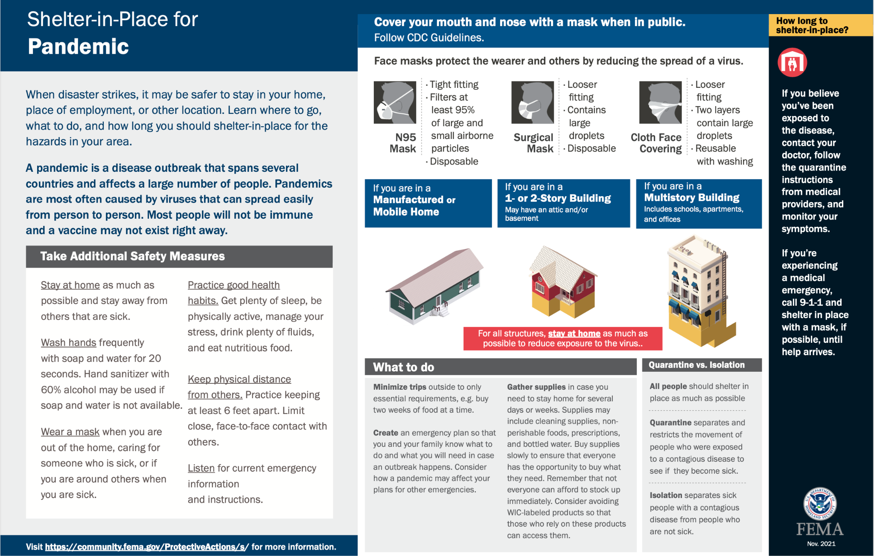
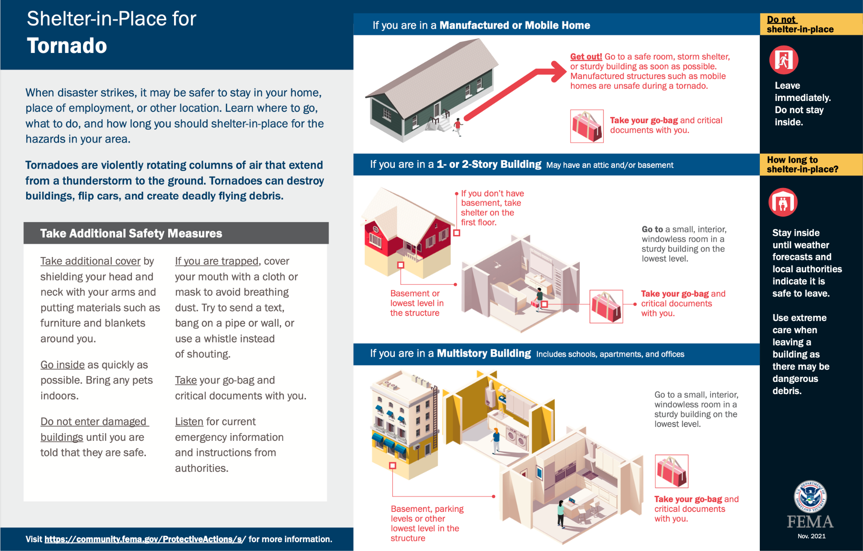
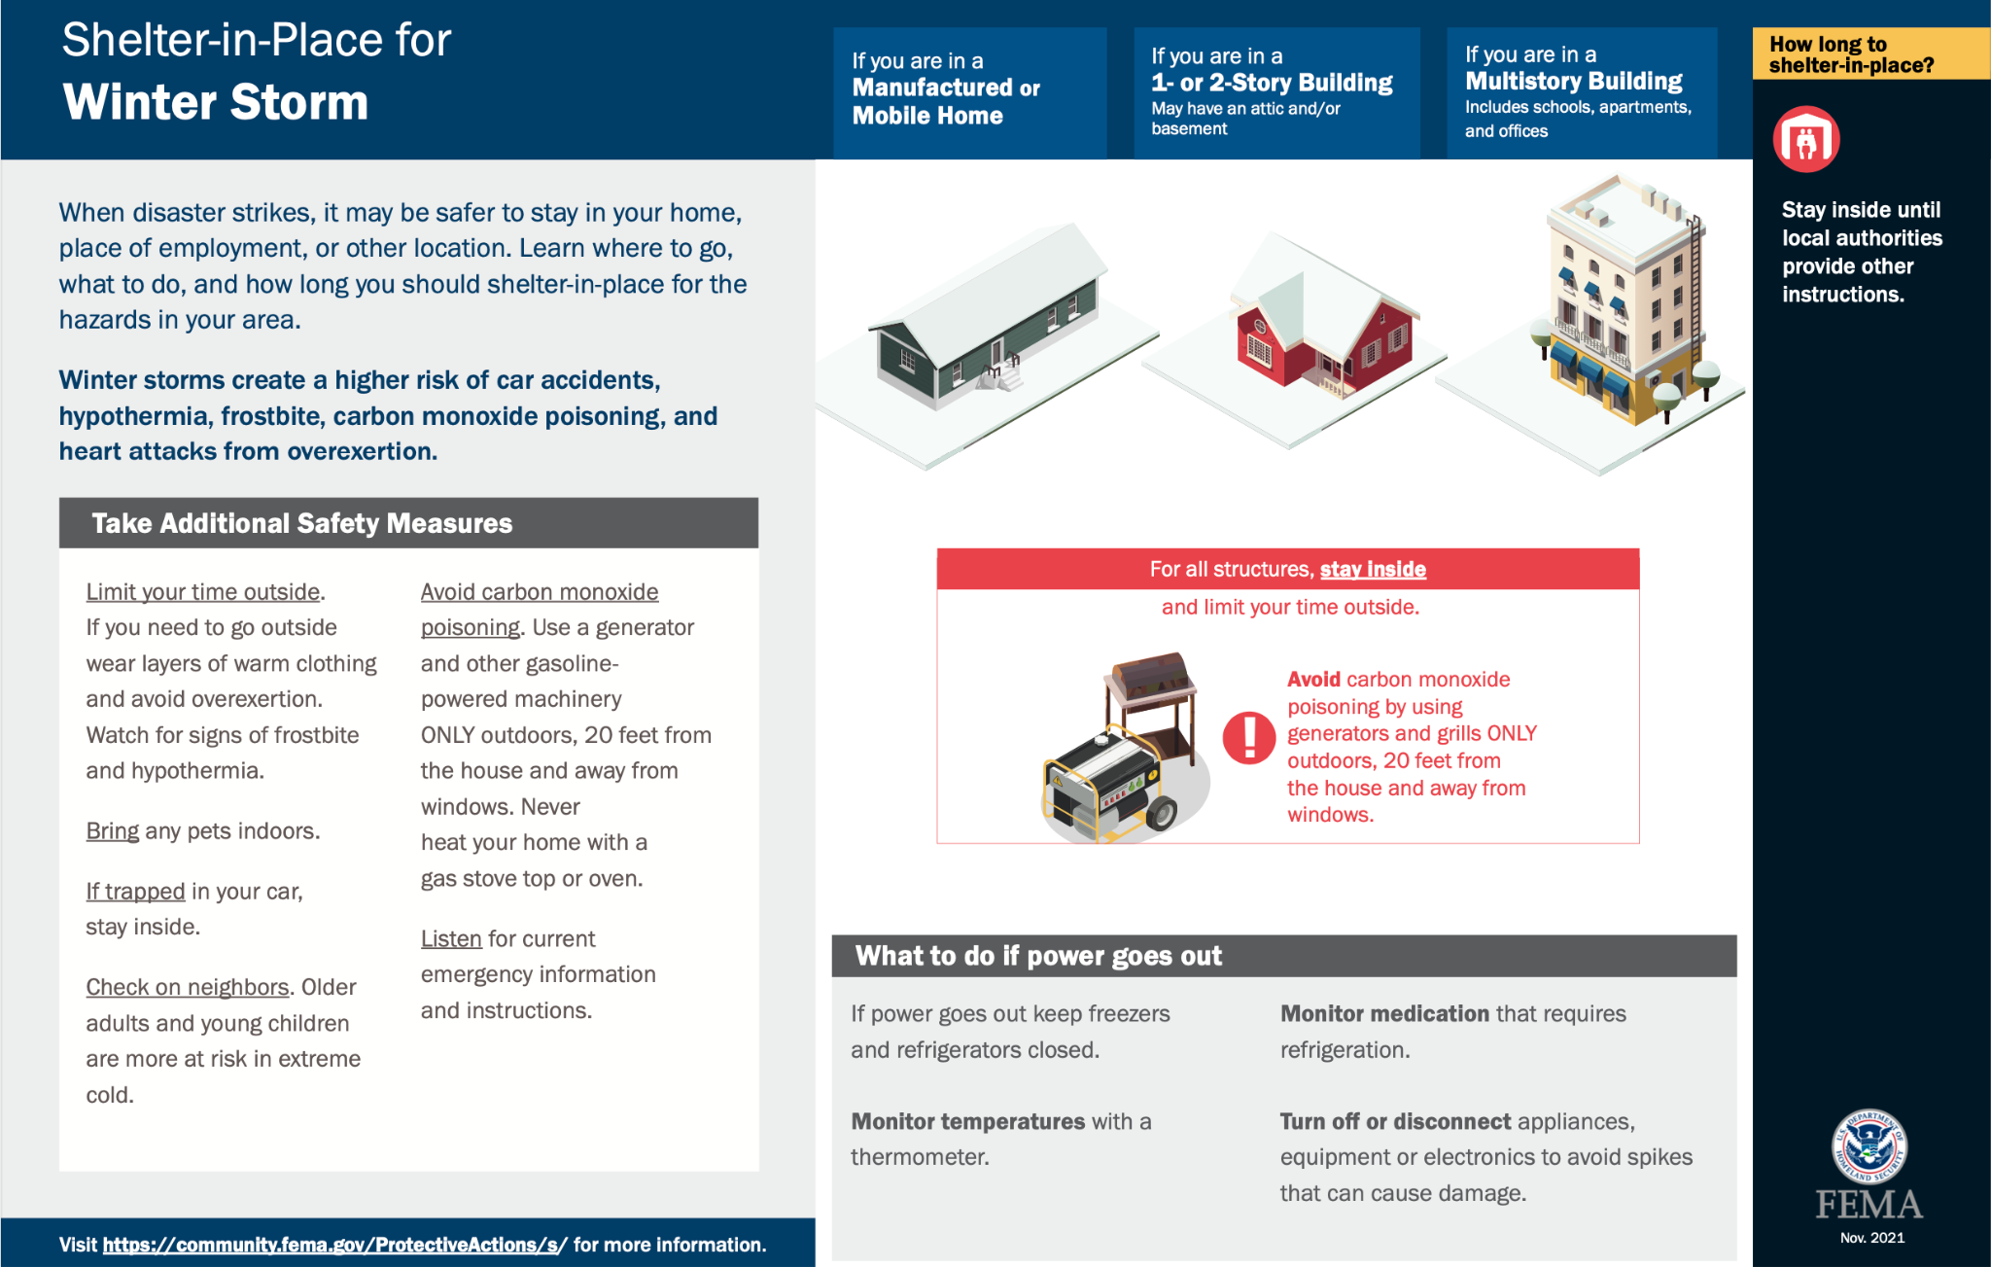
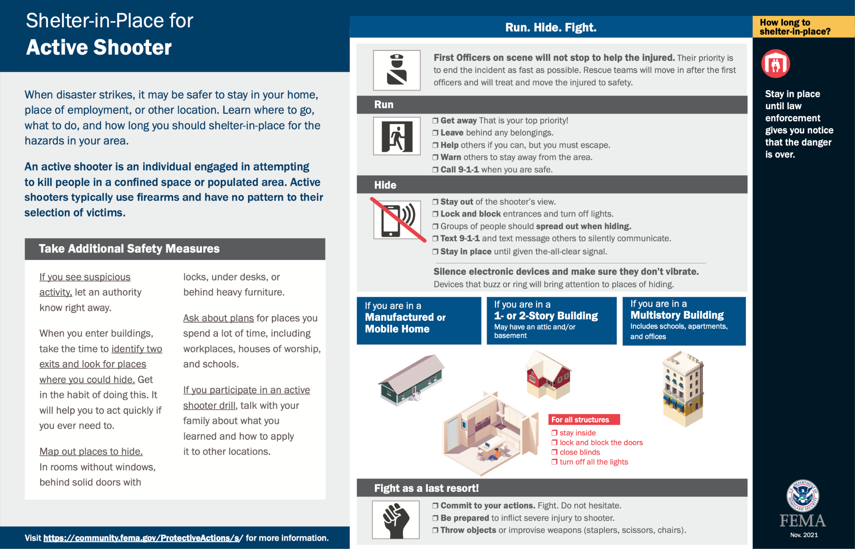
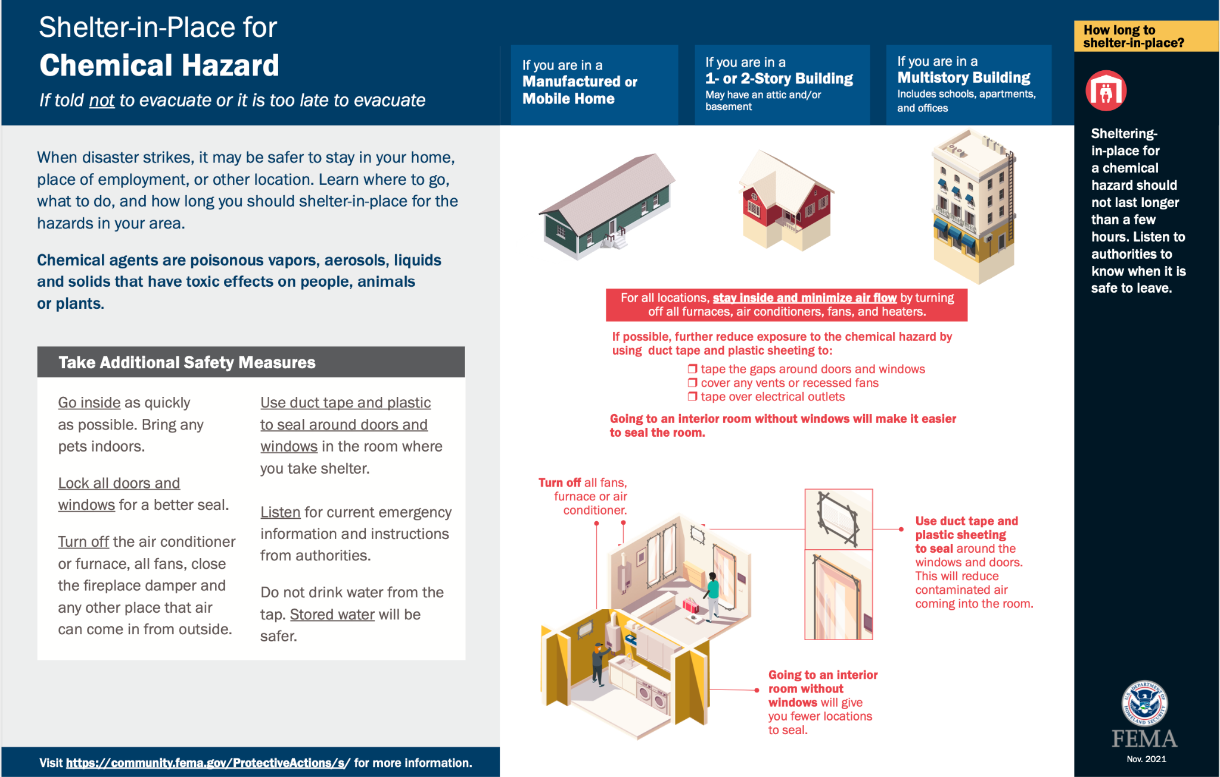
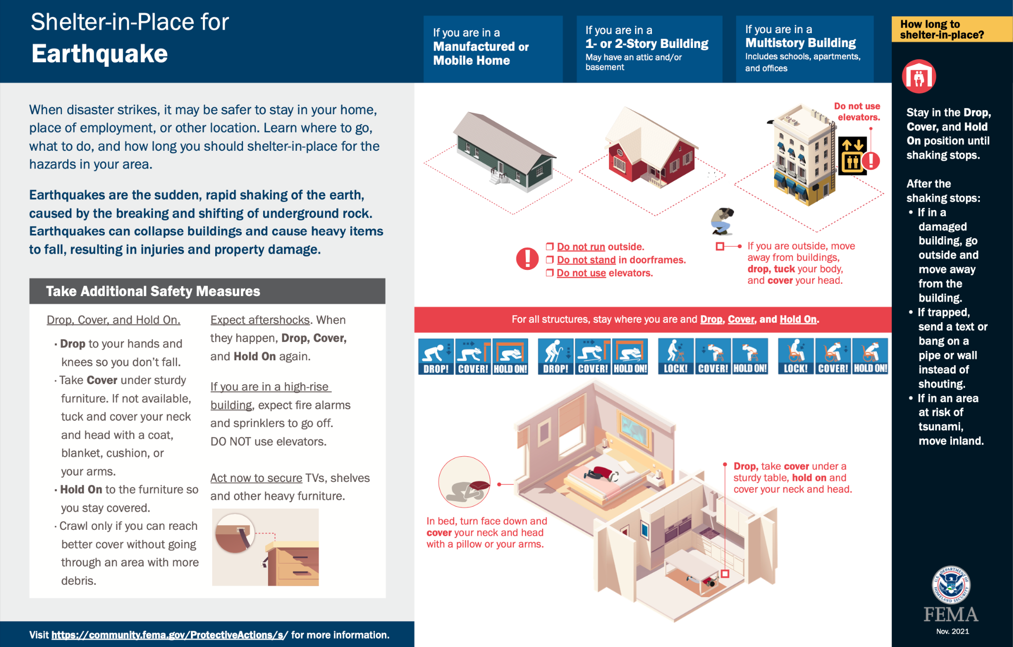
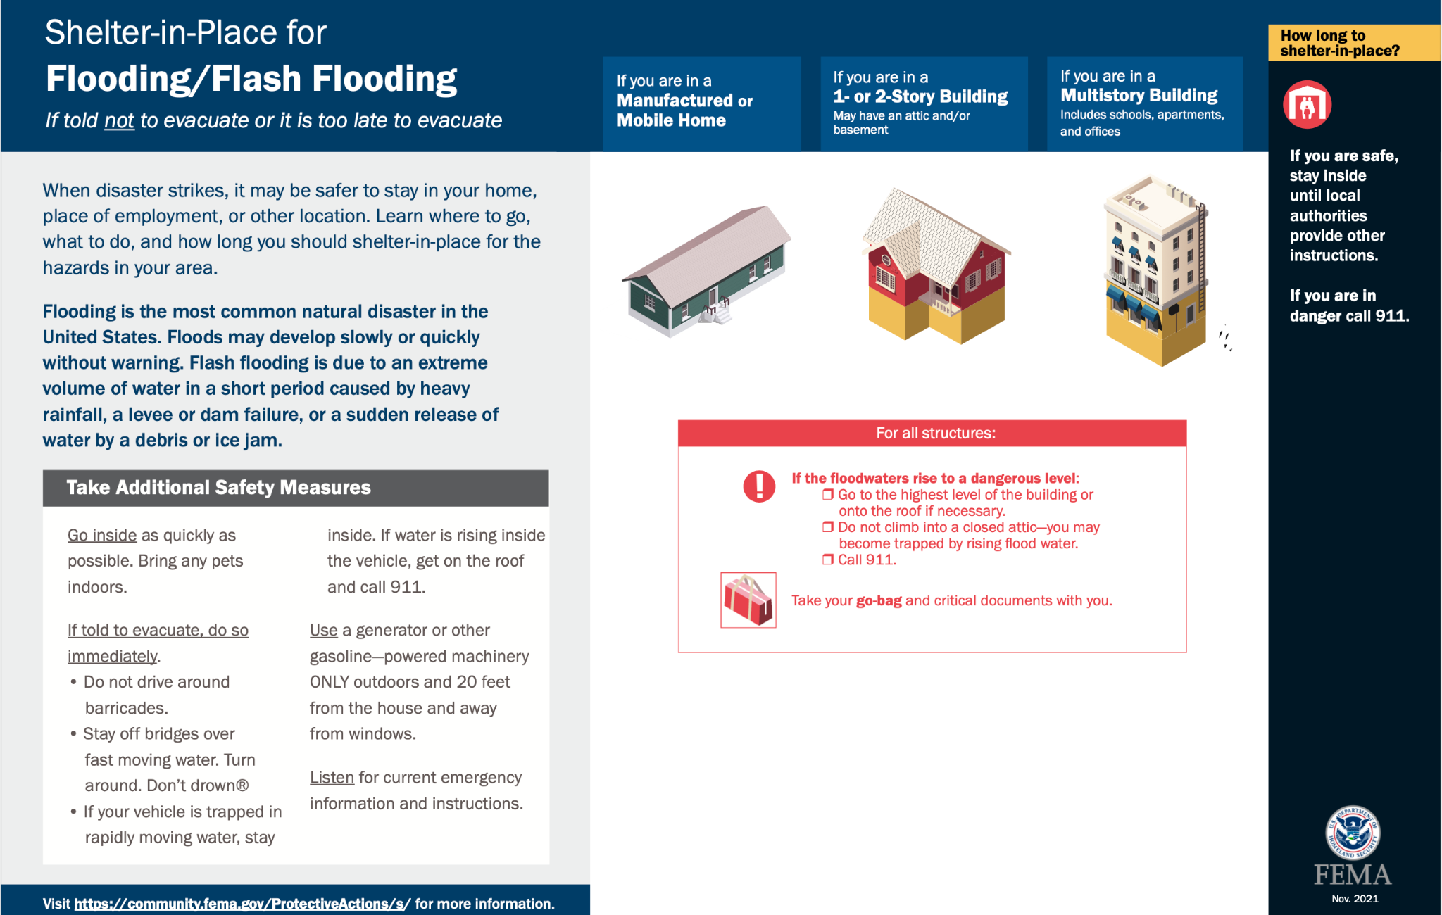
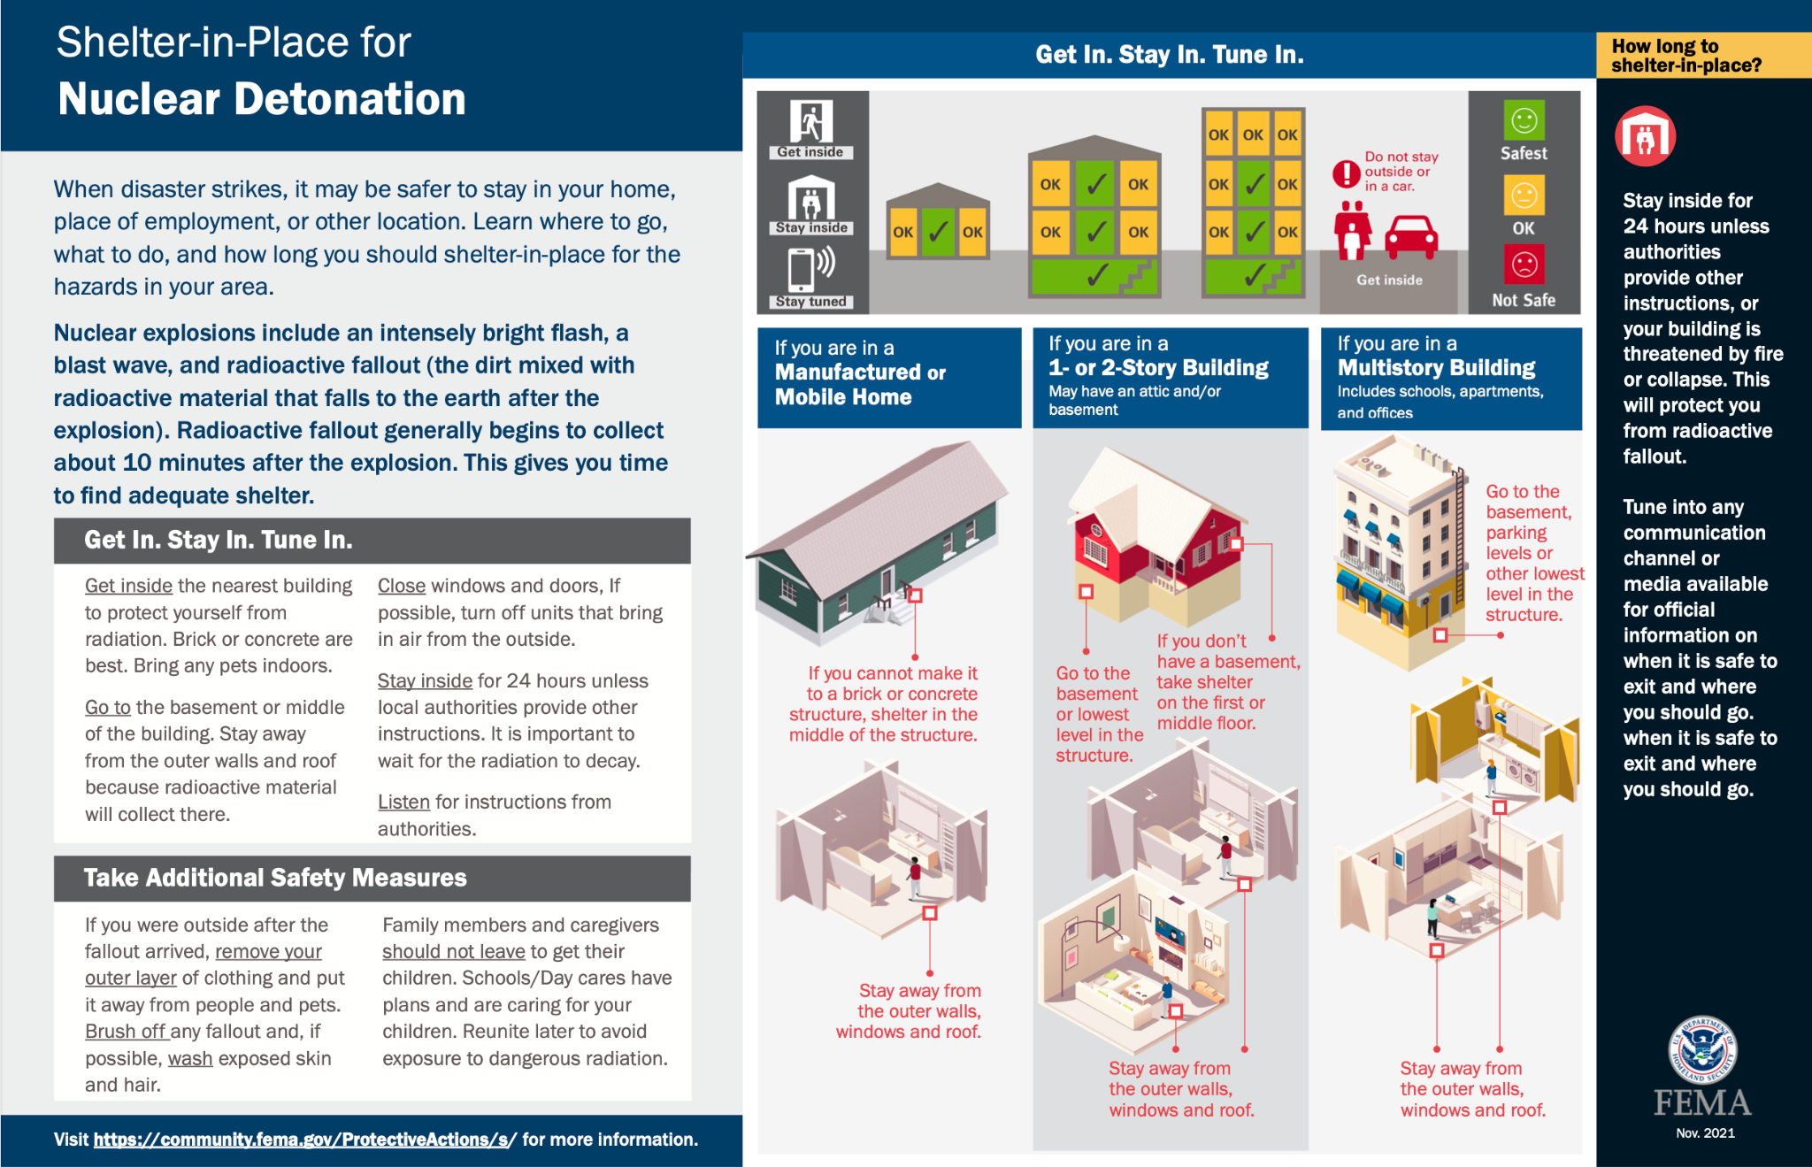 QUIZ AND SIGNATURE PAGE

Instructions:
- Please remove this page from the packet.
- Refer to the Emergency Plan to answer all questions.
- You must get a 12 out of 12 to pass the quiz.
- Print your name, sign and date.
- Give to the Office Manager, your supervisor, or the Exec. Director.
- THANK YOU FOR CARING ABOUT SAFETY AT ST. PATRICK!!!

QUIZ QUESTIONS:

- What number should be dialed in the event of an emergency?
_____________________________________________________________________
- In the event of a major emergency, who is the primary Incident Point Person? Who comes next if that person cannot be found?
_____________________________________________________________________
- In the event of a major emergency, who is the primary Building Point Person? Who comes next if that person cannot be found?
_____________________________________________________________________
- Who would be good candidates for the Medical Response Team? _____________________________________________________________________
- Where are the first aid kits located?
_____________________________________________________________________
- Where are the manual fire alarms located?
_____________________________________________________________________
- Where are fire extinguishers located?
_____________________________________________________________________
- Where is the primary designated assembly area for all emergencies? Secondary location?
_____________________________________________________________________
- Where are the Tornado Shelter Areas for the East and West wings?
__________________________________________________________________________________________________________________________________________
- What are the main evacuation routes for the building?
_____________________________________________________________________
- What is the procedure for an intruder or active shooter? (Hint: Three words)
_____________________________________________________________________
- True or False: This document is a guide but in no way serves as a substitute for making wise and timely decisions in light of real-time events.

__________________________ _________________________ ___________
Printed Name Signature Date

